PROGRAM:

#include <stdio.h>

int main() {

int arr[100], n, key, low = 0, high, mid, i;

printf("Enter size of array: ");

scanf("%d", &n);

printf("Enter %d sorted elements: ", n);

for(i = 0; i < n; i++)

scanf("%d", &arr[i]);

printf("Enter number to search: ");

scanf("%d", &key);

high = n - 1;

while(low <= high) {

mid = (low + high) / 2;

if(arr[mid] == key) {

printf("Found at position %d\n", mid);

return 0;

} else if(arr[mid] < key)

low = mid + 1;

else

high = mid - 1;

}

printf("Not found\n");

return 0;

}

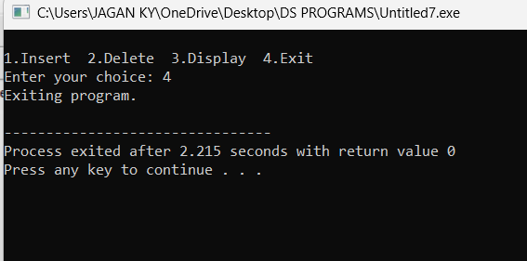

OUTPUT:

